**SOFTWARE CONSTRACTION AND DEVELOPMENT**

Lab Report



**Submitted by:**

**Adil Hussain (12084)**

**BS (SE-5TH) MORNING**

**Date:** 06 April 2021

**Submitted to:** Dr. Uzair Iqbal

**DEPARTMENT OF ENGINEERING**

**NATIONAL UNIVERSTIY OF MODERN LANGUAGES, ISLAMABAD**

Contents

LAB REPORT

TYPE OF UML DIAGRAM 5

LAB_01 6

USE CASE DIAGRAM 6

Use Case Diagram of Online Learning 6

LAB_02 7

USE CASE DIAGRAM GENERALIZATION 7

Use Case Generalization of E Learning 7

LAB_03 8

USE CASE OF TV REMOTE CONTROL 8

Use Case Diagram of Online Learning 8

LAB_04 9

HIGH LEVEL DIAGRAM 9

High Level Diagram of Online Learning 9

LAB_5.1 10

SEQUENCE DIAGRAM 10

Sequence Diagram of Online Learning 10

LAB_5.2 11

SEQUENCE DIAGRAM WITH OBJECT CREATION 11

Sequence Diagram of Online Learning with Object Creation 11

LAB_06 12

REFACTORING OF ACTIVITY DIAGRAM 12

Refactoring Activity Diagram of Online Learning 12

LAB_07 13

REFACTORING SEQUENCE DIAGRAM 13

Refactoring Sequence Diagram of Online Learning 13

# TYPE OF UML DIAGRAM

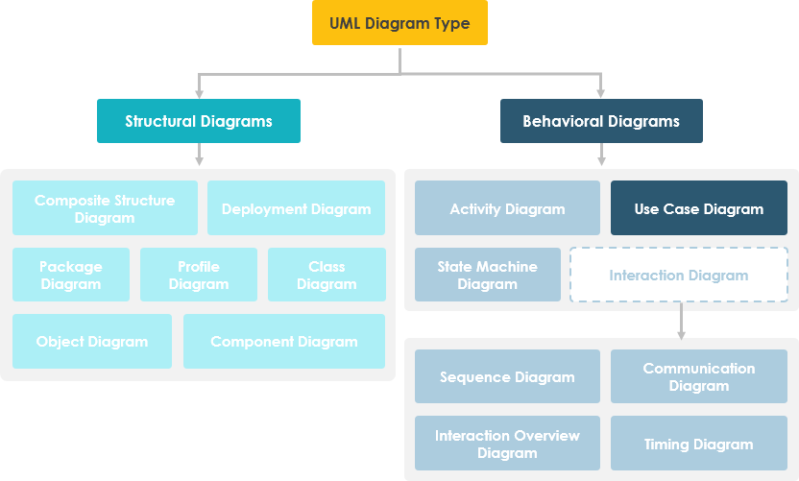

# LAB_01

## USE CASE DIAGRAM

In the Unified Modeling Language (UML), a use case diagram can summarize the details of your system's users (also known as actors) and their interactions with the system. To build one, you'll use a set of specialized symbols and connectors. An effective use case diagram can help your team discuss and represent:

* Scenarios in which your system or application interacts with people, organizations, or external systems
* Goals that your system or application helps those entities (known as actors) achieve
* The scope of your system

### Use Case Diagram of Online Learning

# LAB_02

## USE CASE DIAGRAM GENERALIZATION

In the context of use case modeling the use case generalization refers to the relationship which can exist between two use cases and which shows that one use case (child) inherits the structure, behavior, and relationships of another actor (parent).

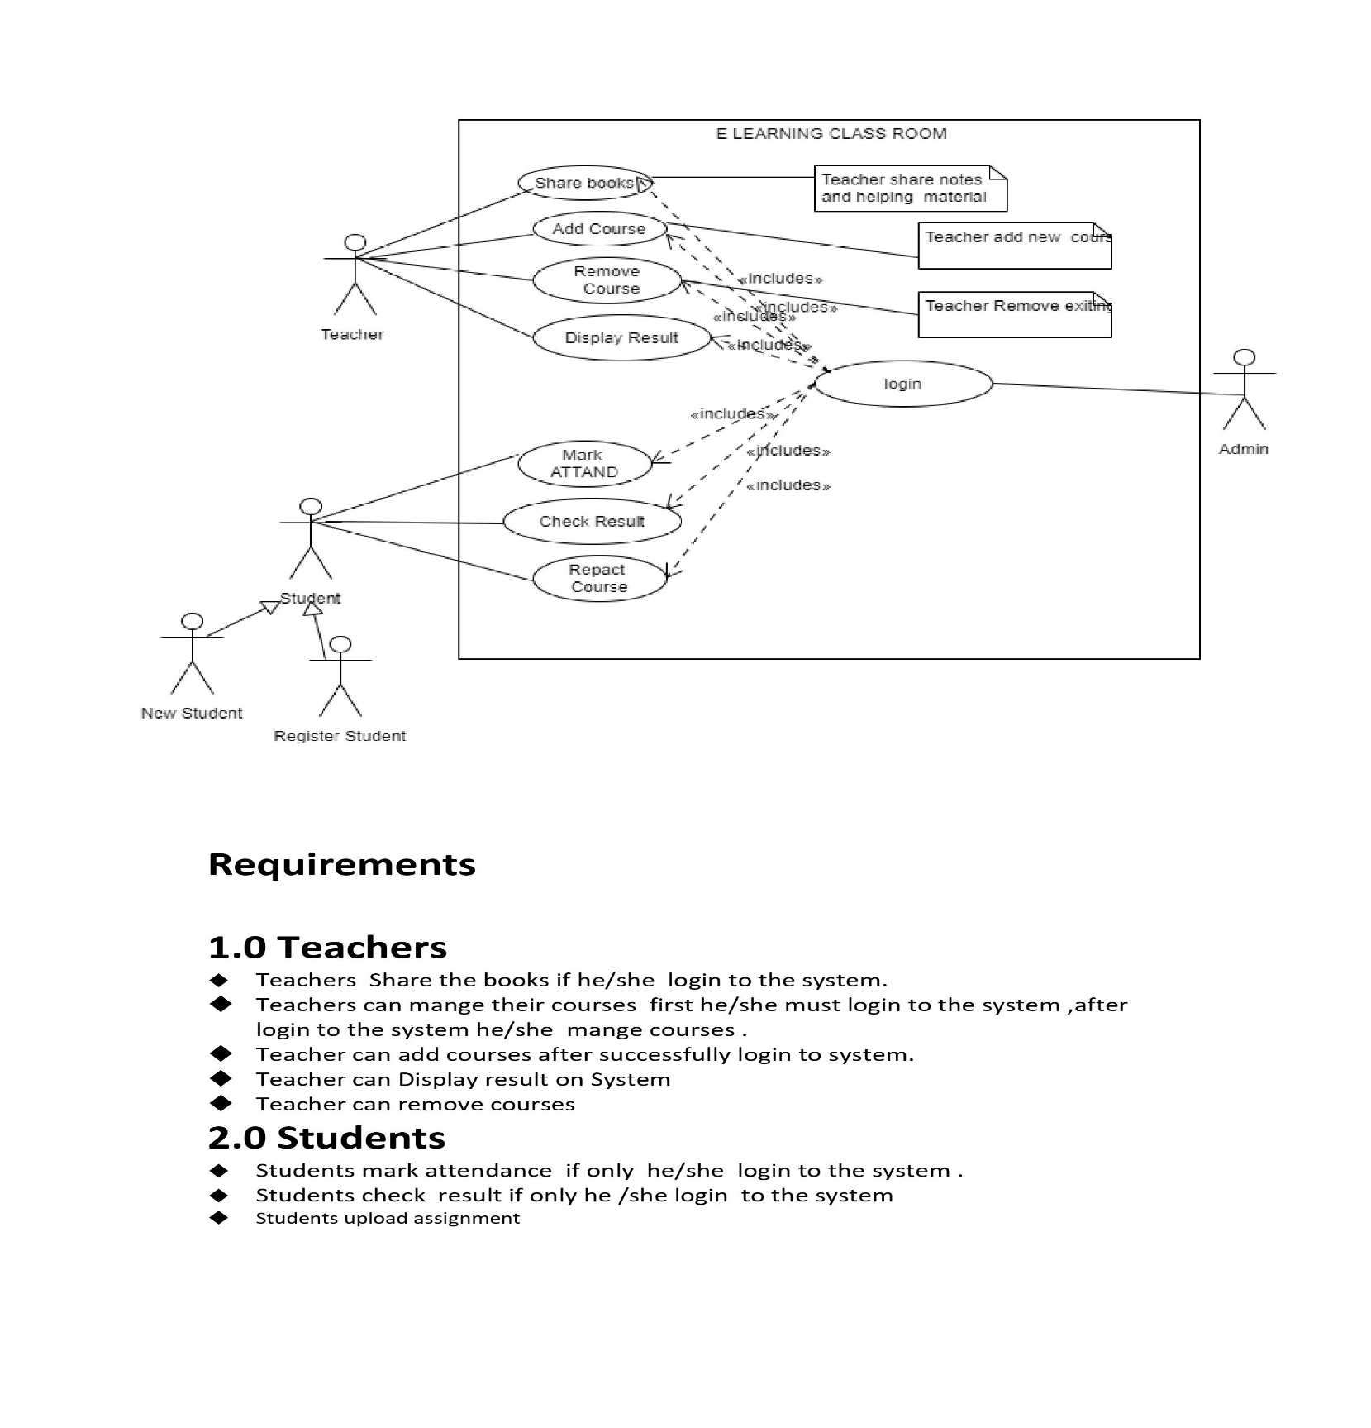

### Use Case Generalization of E Learning

# LAB_03

## USE CASE OF TV REMOTE CONTROL

In electronics, a remote control or clicker is an electronic device used to operate another device from a distance, usually wirelessly. In consumer electronics, a remote control can be used to operate devices such as a television set, DVD player or other home appliance

### Use Case Diagram of Online Learning

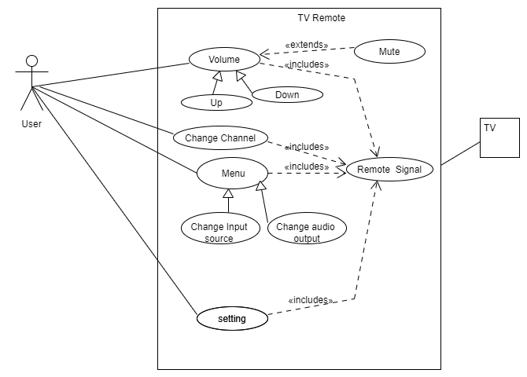

# LAB_04

## HIGH LEVEL DIAGRAM

High-level design explains the architecture that would be used to develop a system. The architecture diagram provides an overview of an entire system, identifying the main components that would be developed for the product and their interfaces.

### High Level Diagram of Online Learning

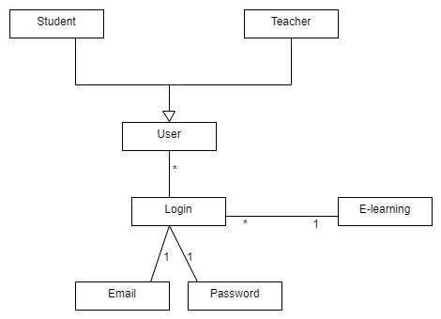

# LAB_5.1

## SEQUENCE DIAGRAM

Sequence diagrams, commonly used by developers, model the interactions between objects in a single use case. They illustrate how the different parts of a system interact with each other to carry out a function, and the order in which the interactions occur when a particular use case is executed.

In simpler words, a sequence diagram shows different parts of a system work in a ‘sequence’ to get something done

### Sequence Diagram of Online Learning

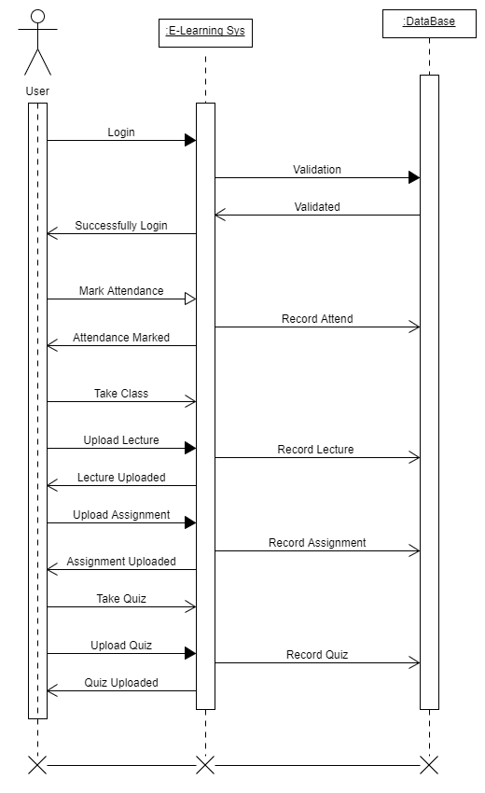

# LAB_5.2

## SEQUENCE DIAGRAM WITH OBJECT CREATION

A sequence diagram shows object interactions arranged in time sequence. It depicts the objects involved in the scenario and the sequence of messages exchanged between the objects needed to carry out the functionality of the scenario. ... Sequence diagrams are sometimes called event diagrams or event scenarios.

### Sequence Diagram of Online Learning with Object Creation

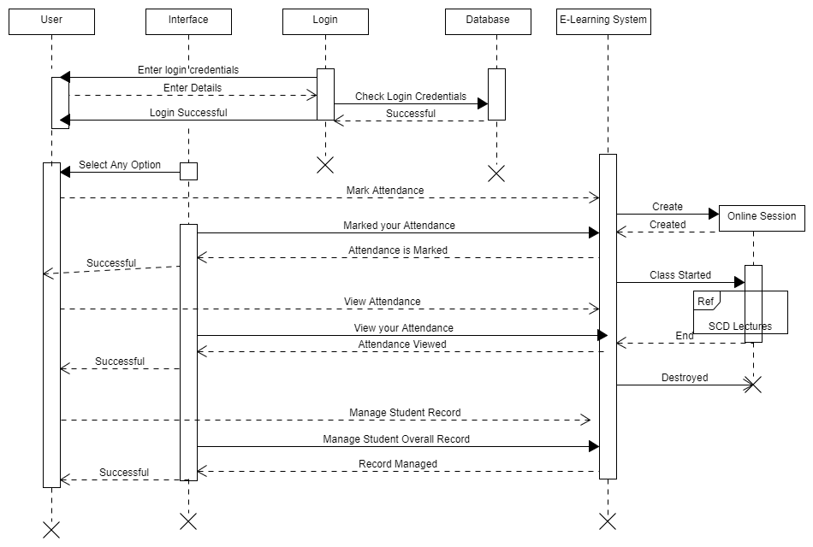

# LAB_06

## REFACTORING OF ACTIVITY DIAGRAM

Model refactoring is the process of transformation of model, which changes its internal structure for improving the qualitative features. Model refactoring should preserve the behavior of the model.

### Refactoring Activity Diagram of Online Learning

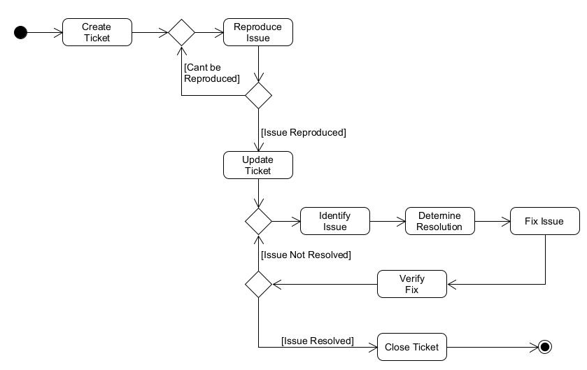

# LAB_07

## REFACTORING SEQUENCE DIAGRAM

Model refactoring is the process of transformation of model, which changes its internal structure for improving the qualitative features. Model refactoring should preserve the behavior of the model.

### Refactoring Sequence Diagram of Online Learning

